**PROJECT DESIGN PHASE-I**

**<<SOLUTION ARCHITECTURE>>**

|  |  |
| --- | --- |
| Date | 15 September 2022 |
| Team ID | PNT2022TMID45285 |
| Project Name | IoT Based gadget for child safety monitoring and notification |
| Maximum Marks | 4 Marks |

PROJECT DESIGN PHASE-1

SOLUTION ARCHITECTURE

Solution Architecture of Child Safety Device:

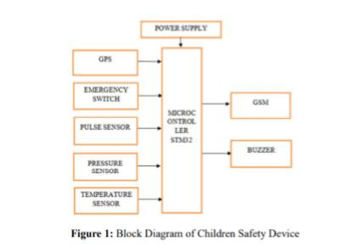

**The above block diagram consists of STM32 microcontroller, GPS module, GSM module,**

Force sensor, temperature sensor, and pulse sensor. Considering all these parameters we have built an

Android app which consist of each parameter separately and the parent can easily monitor it and react

Based on a particular parameter. The device consist of emergency switch which can be turned ON

When the child thinks that he is in danger or being harassed and it also consist force sensor with an

Applied force. When the force exceeds the limit, with this action an alert message will be sent to the

Parent who consists of location of the child. If these two cases are failed to be applied then the device

Will be having a pulse sensor which will keep on reading the pulse rate of the child, then the parent gets an alarm message showing that the child’s pulse is being raised by which the parent will able to

access the android app and check the location of the child and act accordingly.

1. GPS Module

The complete GPS module that is based on the Ublox NEO-6M. This unit uses the latest

Technology from Ublox to give the best possible positioning information and includes a larger built-in

25 x 25mm active GPS antenna with a UART TTL socket. A battery is also included so that you can

Obtain a GPS lock faster. This is an updated GPS module that can be used with ardupilot mega v2.

This GPS module gives the best possible position information, allowing for better performance with

Your Ardupilot or other Multirotor control platform. The NEO-6M GPS module is shown in the figure

2. It comes with an external antenna, and doesn’t come with header pins.

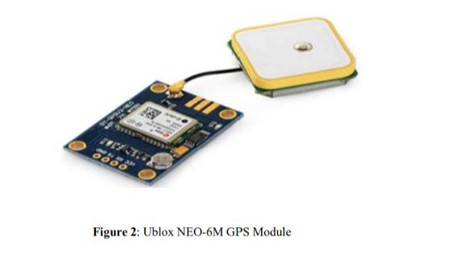

**\*RESULTS AND DISCUSSION:**

**When the power supply is given to the device, all the modules get activated as shown as figure.**

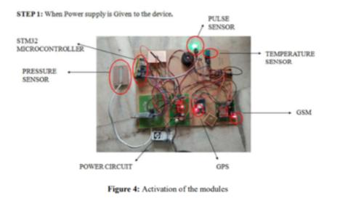

Step-2

When the emergency switch is turned on, the buzzer gets activated and the GPS device starts

Tracking the child and takes the latitude and longitude from the satellite which resembles the position of the child as shown in the figure 5.

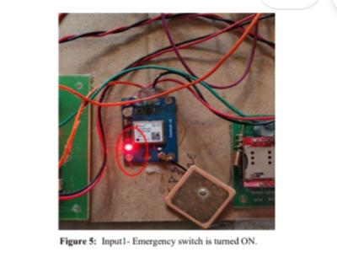

Step -3

In case the emergency switch cannot be turned on, there is pressure sensor in the device

Which has a limit of certain pressure. If the applied pressure is beyond that limit the sensor gets

Activated and gives as input to STM32 microcontroller and the buzzer gets turned on to alert the

Surroundings, then the GPS device starts tracking the child and takes the latitude and longitude from

The satellite which resembles the position of the child as shown in the figure 6.